Doubt or Hesitation Interjections

🔹 What Are Doubt or Hesitation Interjections?
# Source: AI Source: Provided by: [Data Path: Persons Table -> ID Column: 1, Name_En Column: Motasem Essam] -> From: [Chatgpt (GPT-4-turbo)] on [7/28/2025]
Doubt or hesitation interjections are short expressions used to show uncertainty, confusion, indecision, or a pause while thinking.
They often appear in spoken English and convey that the speaker is unsure or needs a moment to think.

✅ Key Features
# Source: AI Source: Provided by: [Data Path: Persons Table -> ID Column: 1, Name_En Column: Motasem Essam] -> From: [Chatgpt (GPT-4-turbo)] on [7/28/2025]
- Express doubt, indecision, or mental processing
- Often used to stall while thinking or responding
- Usually followed by commas, pauses, or longer responses
- Common in casual speech, not formal writing

🧩 Common Doubt or Hesitation Interjections
# Source: AI Source: Provided by: [Data Path: Persons Table -> ID Column: 1, Name_En Column: Motasem Essam] -> From: [Chatgpt (GPT-4-turbo)] on [7/28/2025]
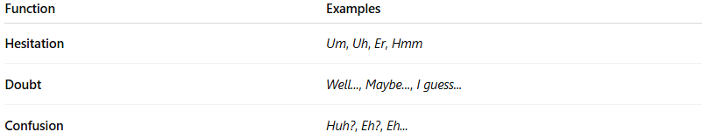
Function | Examples
Hesitation | Um, Uh, Er, Hmm
Doubt | Well..., Maybe..., I guess...
Confusion | Huh?, Eh?, Eh...

📚 Example Sentences
# Source: AI Source: Provided by: [Data Path: Persons Table -> ID Column: 1, Name_En Column: Motasem Essam] -> From: [Chatgpt (GPT-4-turbo)] on [7/28/2025]
- Um, I’m not sure what to say. (hesitation)
- Well... I don’t know if that’s a good idea. (doubt)
- Hmm, let me think for a moment. (pause for thought)
- Uh, where did I leave my keys? (thinking or unsure)
- Huh? What did you mean by that? (confusion)

